ReactJS Hands-on 2 - Student Management Portal

Project Structure
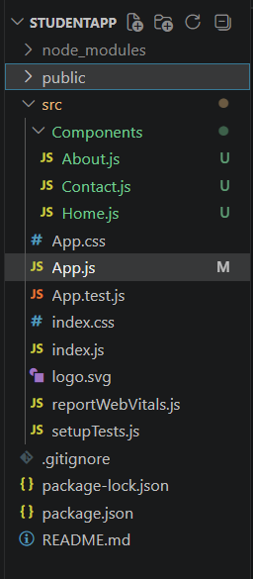

Home.js
function Home() {
return (
<h2>Welcome to the Home page of Student Management Portal</h2>
);
}
export default Home;

About.js
function About() {
return (
<h2>Welcome to the About page of the Student Management Portal</h2>
);
}
export default About;

Contact.js
function Contact() {
return (
<h2>Welcome to the Contact page of the Student Management Portal</h2>
);
}
export default Contact;

App.js
import Home from "./Components/Home";
import About from "./Components/About";
import Contact from "./Components/Contact";
function App() {
return (
<div>
<Home />
<About />
<Contact />
</div>
);
}
export default App;

Expected Output
Welcome to the Home page of Student Management Portal
Welcome to the About page of the Student Management Portal
Welcome to the Contact page of the Student Management Portal
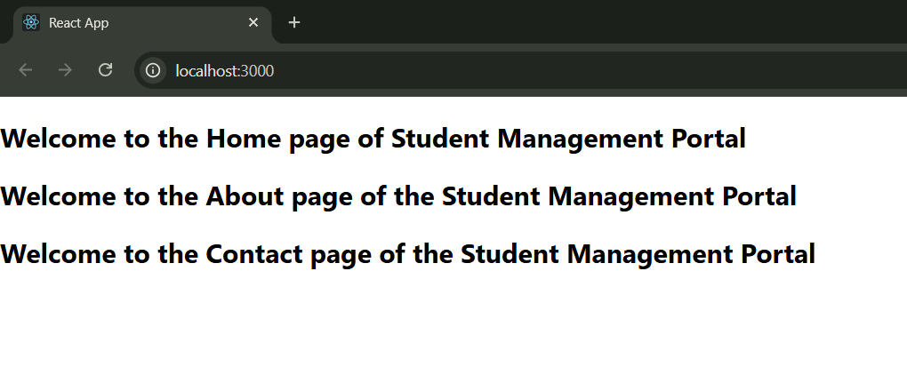

Result
The Student Management Portal React application was created successfully and all three components were rendered successfully.

